

American International University- Bangladesh

CSC 3222: Web Technologies

CO1.1 and CO2.1 Evaluation

Project Report

Spring 21-22

Project Title: Online Pet Store(Paw it Forward)

Section: F

| Student Name | Student Id |
| --- | --- |
| Afsana Sultana | 21-45917-3 |
| Sadiah Alansar | 21-45612-3 |
|  |  |
|  |  |

Introduction:

We chose an online pet store so that it can offer convenient doorstep delivery, saving customers time. This is particularly valuable for pet owners with busy lifestyles and cost efficient for the customers and the shop owner by reducing the physical store bills. It will allow for quick updates to inventory, pricing, and promotions, enabling the owner to adapt to customer demands.

Background Study

Website reference: <https://www.w3schools.com/>, <https://www.learn-php.org/> <https://www.youtube.com/>

Online Vet Shop,Paw it Forward is a one-stop shop for all things pet-related. This platform responds to the increasing need for accessible veterinary solutions by providing a wide array of goods and services, including as grooming supplies, supplements, prescription drugs, and online consultations with certified veterinarians. Our aim is to offer pet owners a dependable and hassle-free experience through a user-friendly website, secure payment methods, and adherence to regulations. We want to differentiate ourselves from the competition and earn your trust by becoming your go-to partner for pet care and digital marketing. Our goal is to establish Paw it Forward as a leading brand in the online pet care industry through constant innovation and growth.

Requirement Analysis:

1. User Category:

There are 3-types of Users here. They are:

* Admin
* Doctor
* Customer

1. Feature List:

In this project the “Admin” has the following features:

* Login
* Registration
* Add user
* Delete user
* See user list
* logout

In this project the “Doctor” has the following features:

* See Appointments
* Take Appointments
* Give Nutrition Guide

In this project the “Customer” has the following features:

* Book Doctor’s Appointments
* See list of products
* Place an Order
* Comment
* Give Review
* Logout
* Login
* Confirm Order
* FAQ
* Dashboard

Design:

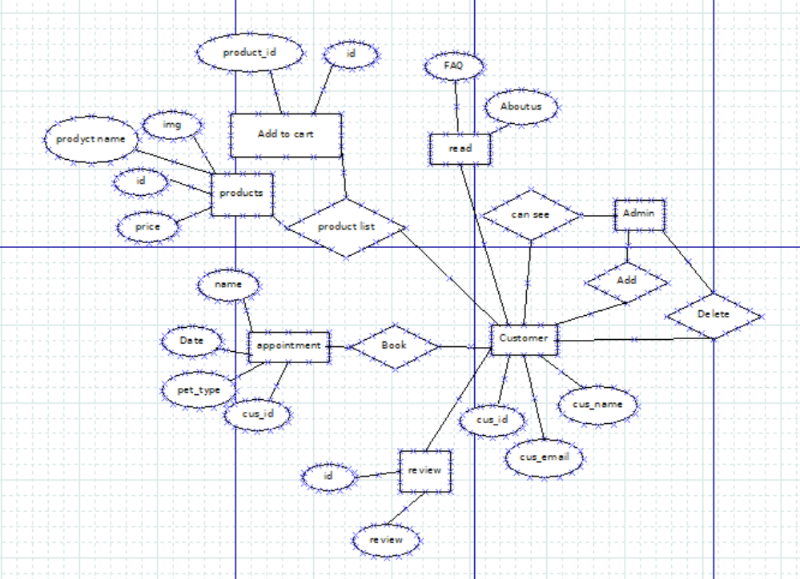

Tools Used:

To develop this project, we have used the following:

• Visual Studio Code

• Xampp

• mySql

• Github

• Chrome

System Images against the Specification:

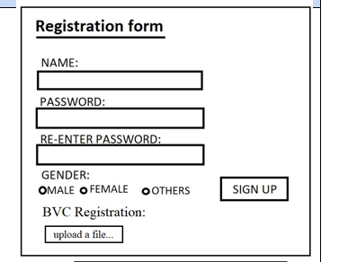

Users can register in this form if they are new to the store.

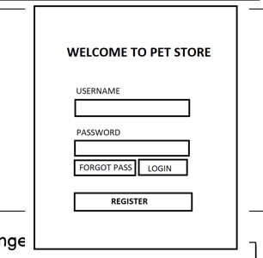

If users are already registered, they can login with this form.

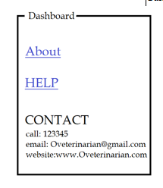

Users can get ideas about the software and seek any help they need, they can contact the owner in the updated contacts.

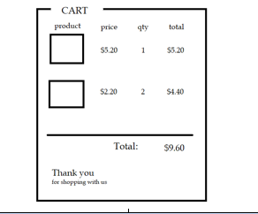

After selecting the product to buy, the total product prices are showed to proceed to checkout.

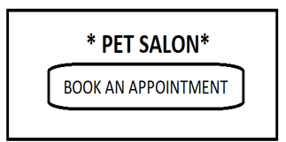

Users can book their necessary appointments with a pet salon.

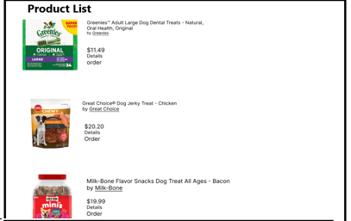

All the products that are available in the store are shown and updated regularly.

Impact of this Project:

Online pet store can help improve pet owners' shopping experience by being able to place orders quickly and efficiently. It can reduce time consumption to go to a physical store to buy their pets necessary items or book an appointment with the doctor. They can easily book doctors appointments from their homes and also book salon appointments. Customers can get their orders delivered at home quickly.

Limitations and Possible Future Improvements:

Customers are not able to leave reviews with pictures, the checkout process is not very smooth and it is difficult to find products. We can improve the browsing process for customers to find products effortlessly. Enhance the mobile experience with a responsive design, ensuring that the online store is accessible and functional on various devices. We can simplify the checkout process to minimize steps. Allow customers to leave reviews with images, and implement a rating system.

| CO1.1 and CO2.1 Evaluation: Project Report Evaluation | | | | | |
| --- | --- | --- | --- | --- | --- |
| Project Proposal  (5) | Background  Study  (5) | Requirement Analysis  (5) | Entity  Diagram  (5) | System Images  against the  Specification (5) | Total (25) |
|  |  |  |  |  |  |
|  | | | | | |